# MANGALORE INSTITUTE OF TECHNOLOGY & ENGINEERING



(A unit of Rajalaxmi Education Trust ®, Mangalore)

**Autonomous Institute Affiliated to V.T.U., Belagavi , Approved by AICTE, New Delhi**

Accredited by NAAC with A+ Grade & an ISO 9001:2015 Certified Institution

**Department of Computer Science & Engineering** *(Accredited by NBA)*

**Mini Project Synopsis on Database Management Systems Laboratory with**

**Mini Project (21CSL55)**

**(2023-2024)**

**“Examination System”**

**Mini Project Group Members:**

|  |  |  |  |
| --- | --- | --- | --- |
| **SI.NO.** | **STUDENT NAME** | **USN** | **STUDENT SIGNATUTRE** |
| 01 | Dhanush A | 4MT21CS046 |  |
| 02 | Dhanush S Shetty | 4MT21CS047 |  |
| 03 | Karthik U Shettigar | 4MT21CS064 |  |

**Name and Signature of the Guide:**

**Sowmya S**

**Department of Computer Science & Engineering**

# MANGALORE INSTITUTE OF TECHNOLOGY & ENGINEERING

(A unit of Rajalaxmi Education Trust ®, Mangalore)

**Autonomous Institute Affiliated to V.T.U., Belagavi , Approved by AICTE, New Delhi**  Accredited by NAAC with A+ Grade & an ISO 9001:2015 Certified Institution



*(Accredited by NBA)*

## ABSTRACT

**Problem statement:** Designing the database which enables the Students & Teachers to register for the system. Students are allowed to take the online test and see their progress. Also, to enable the Teachers to add, delete, update the test Questions and also to keep track of the Student’s progress.

**Objectives:**

**User Registration:** Allow students and teachers to register for the system, providing necessary information such as username, password, email, and personal details.

**Implementation:** Create a "Users" table with fields like UserID, Username, Password, Email, UserType (Student/Teacher), and additional profile information.

**Student Test Progress:** Enable students to take online tests and view their progress and results.

**Implementation:** Establish a "Tests" table to store test information and a "Results" table to store individual student results linked to the "Users" table through UserID.

**Teacher Test Management:** Allow teachers to add, delete, and update test questions.

**Implementation:** Create a "Questions" table to store questions with fields like QuestionID, TestID, QuestionText, and Answer. Link the "Questions" table to the "Tests" table to associate questions with specific tests.

**Student Progress Tracking:** Enable teachers to track and monitor students' progress and performance.

**Implementation:** Use the "Results" table to store student performance data, linking to the "Users" table via UserID. Teachers can use this data for analysis and reporting.

**Authentication and Authorization:** Implement secure user authentication and authorization mechanisms.

**Implementation:** Utilize encryption for sensitive data, implement proper authentication processes, and set user roles (Student/Teacher) with associated permissions to control access to specific functionalities.

**Test and Question Management:** Facilitate the organization of tests and questions for effective management.

**Implementation:** Utilize a "Tests" table to store test details and a "Questions" table for managing questions. Establish relationships between these tables to maintain integrity and organization.

**Logging and Auditing:** Keep a log of important system activities for auditing purposes.

**Implementation:** Create a "Log" table to record events such as user logins, test submissions, and any modifications to questions or tests. Include fields like LogID, UserID, Activity, Timestamp, etc.

**Description:**

**Proposed System:** In this project, we are designing a database that can be used to

insert, retrieve, update and perform additional operations.

**General Description of Inputs & Outputs:** The system will be getting input from the Users from

various Pages. The output also given by the system depending on input given by the User.

**Continuous updating of database:** Database is updated from time to time after each

effect on the proposal. So data is more accurate and perfect as all the updation is

done simultaneously. The database will be updated by the Teacher in Timely manner.

**Instantaneous retrieval of data:** As the database is update from time to time the data

can updated any time by Teachers and Students can take exam any time.

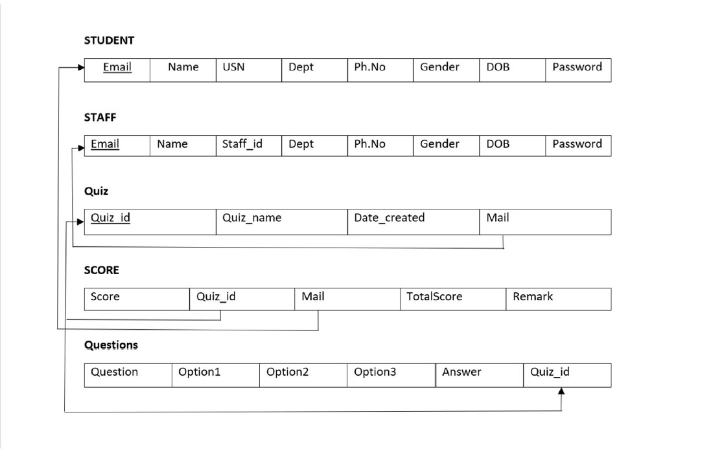**Schema Diagram:**

**ER Diagram:**

